What is RAM? (Deep, Practical & Technical Explanation)
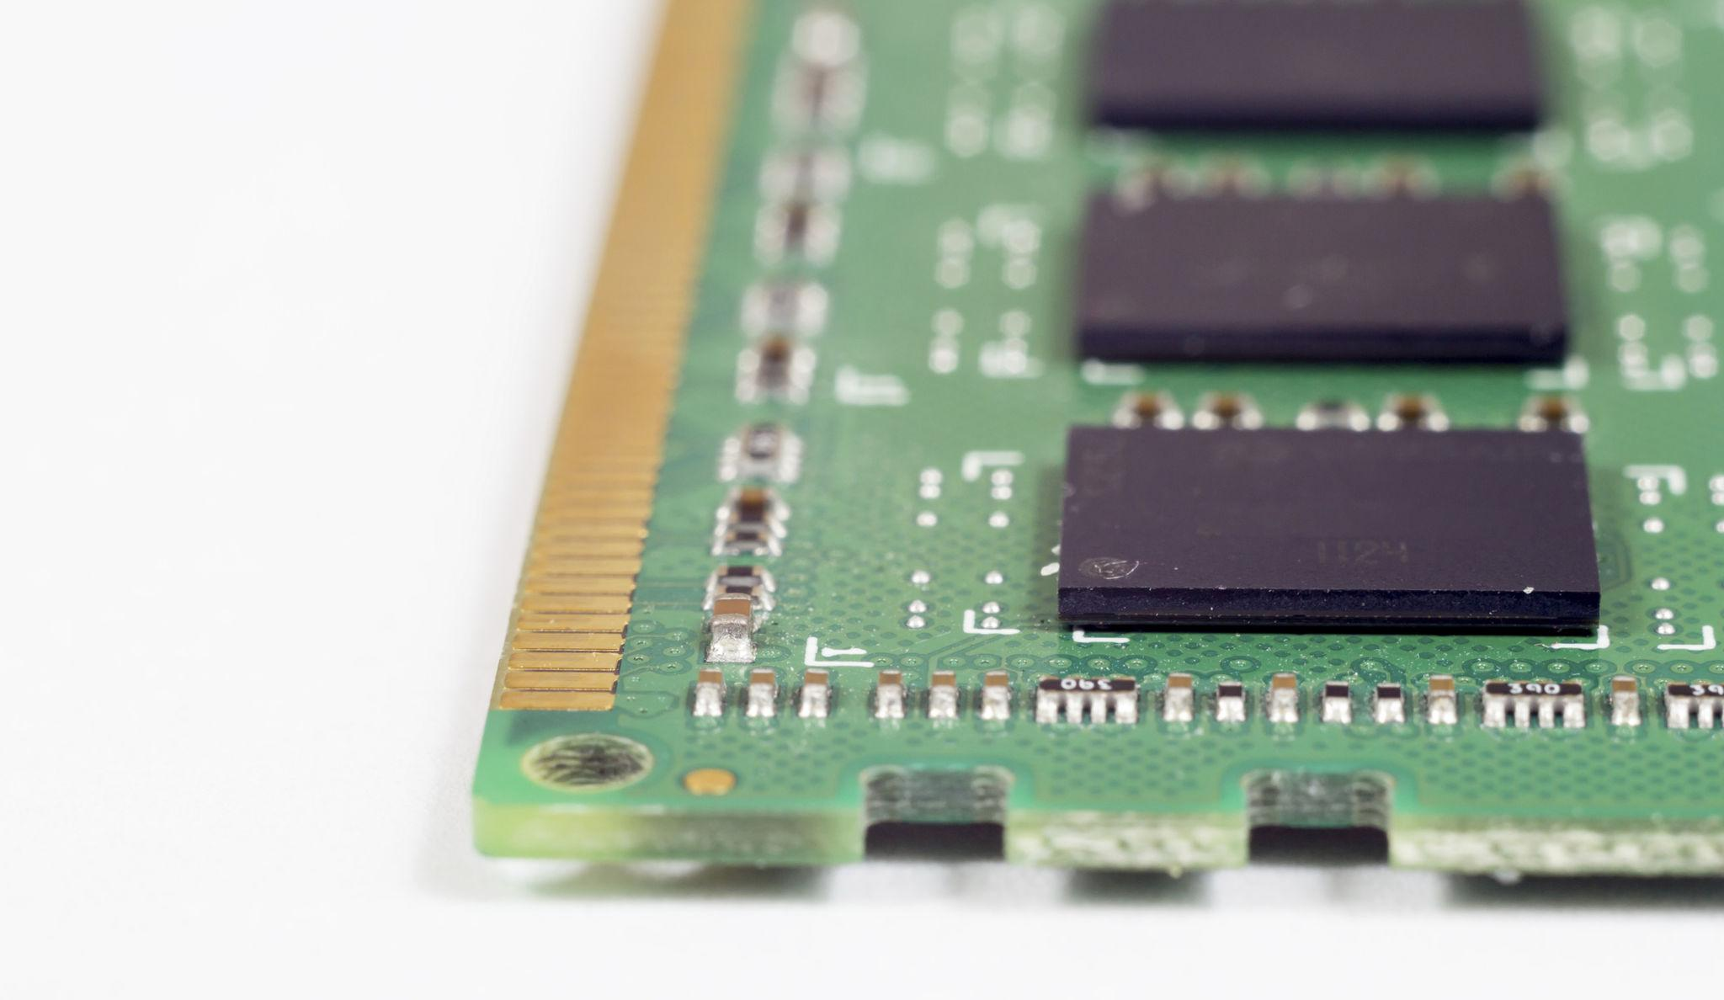

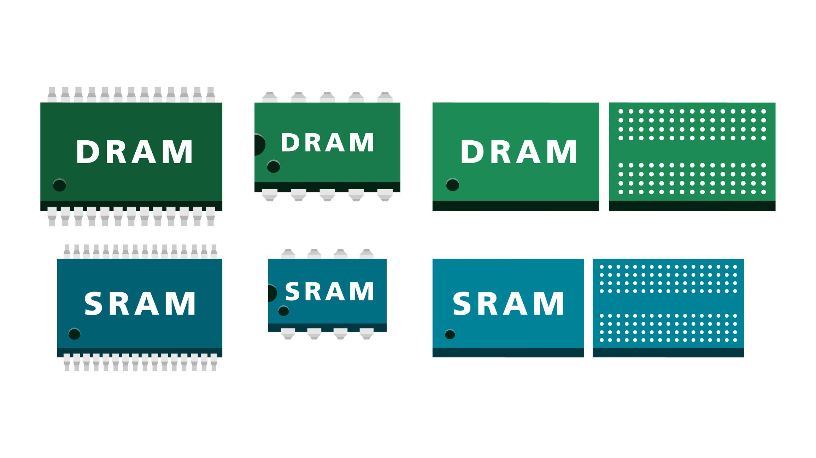
4
💾 RAM = Temporary Working Memory
RAM (Random Access Memory) is the active workspace of your computer.
- Stores running programs
- Stores currently open files
- Stores background processes
- Stores OS tasks
🔄 Clears when power is off
RAM is volatile memory.
When power goes off → all data is erased.

🏗 Where RAM Sits in Memory Hierarchy
Level | Speed | Size | Example
Cache | Fastest | Very small | Inside CPU
RAM | Very fast | Medium | 8–64GB
SSD | Slower | Large | 512GB–2TB
HDD | Slowest | Very large | 1TB+
CPU asks RAM for data thousands of times per second.

🚨 Low RAM = Lag & Crashes (Why?)
When RAM is full:
- System uses page file (virtual memory) on SSD
- SSD is much slower than RAM
- System becomes slow
- Apps may crash
This is called memory swapping.

📊 RAM Capacity Truth
8 GB → Basic
- Browsing
- Office
- Light coding
- Online classes
⚠️ Struggles with:
- Heavy Chrome tabs
- Android Studio
- Virtual machines

16 GB → Recommended (Sweet Spot)
- Coding
- Multitasking
- Light video editing
- Most students & developers
👉 Best balance today.

32 GB → Heavy Tasks
- AI models
- Simulations
- Rendering
- Virtual machines
- Large datasets

❌ More RAM ≠ Faster PC Always
If your system only uses 10GB,
adding 64GB won’t increase speed.
RAM improves stability under load, not raw CPU speed.

⚡ RAM Speed vs Latency (Very Important)
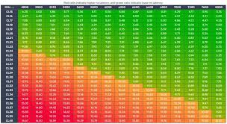
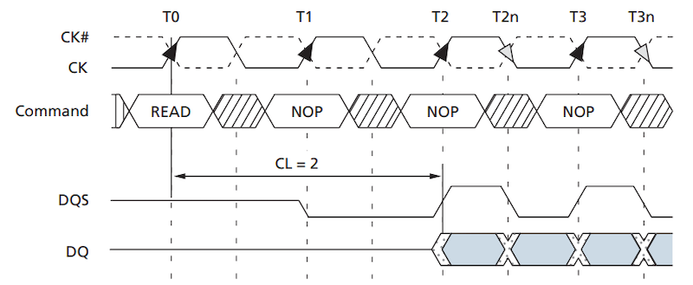
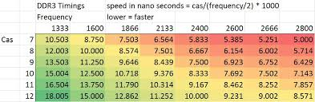
MHz (Frequency)
- Measured in MHz
- Example: 3200 MHz
- Higher MHz = more data transferred per second
CL (CAS Latency)
- Measured as a number (e.g., CL16)
- Lower = faster response

⚖ Both Matter Together
Example:
RAM | Speed | Latency
3200 CL16 | Balanced | Good
3600 CL18 | Slightly higher bandwidth
3200 CL22 | Slower response
📌 Effective latency matters more than just MHz.

🔬 DDR4 vs DDR5 (In-Depth)

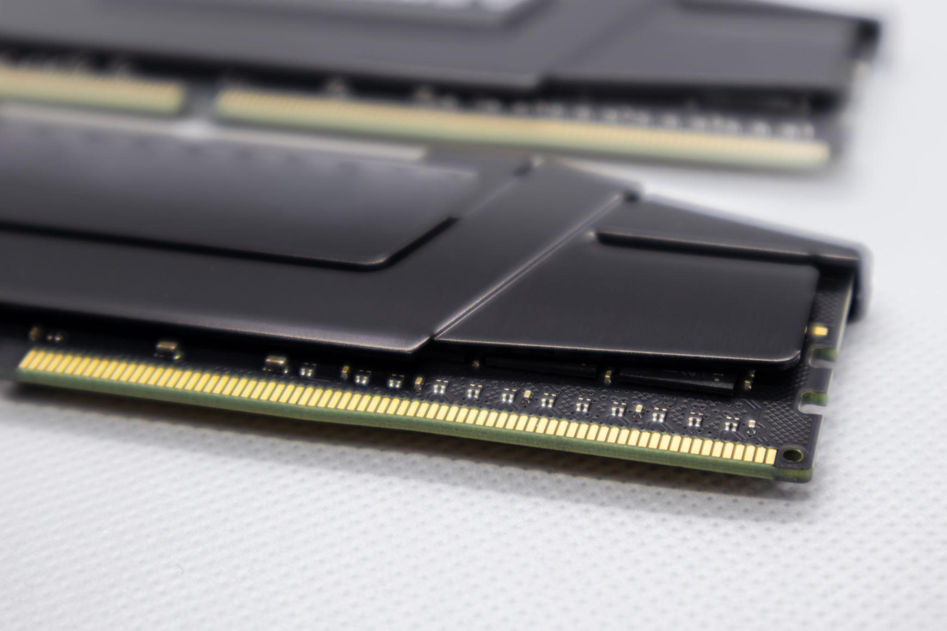
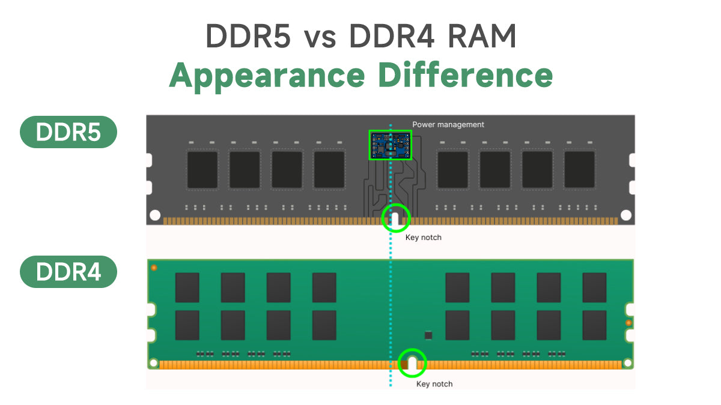
DDR4
✓ Cheaper
✓ Mature ecosystem
✓ Stable
✓ Works with older CPUs
Speed range: 2133–3600 MHz typically

DDR5
✓ Higher base speed
✓ Better power efficiency
✓ On-module power management
✓ Larger memory bandwidth
Speed range: 4800–8000+ MHz
⚠️ Not interchangeable
- DDR4 board → cannot use DDR5
- DDR5 board → cannot use DDR4

🔄 Dual Channel Concept
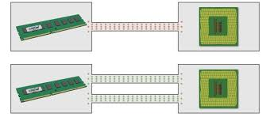
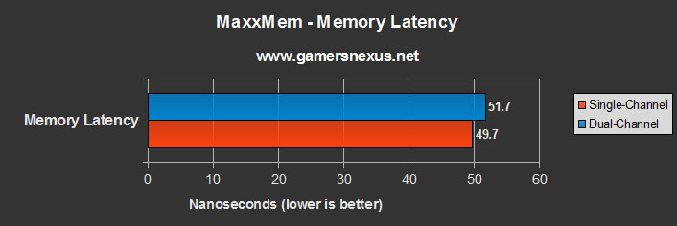
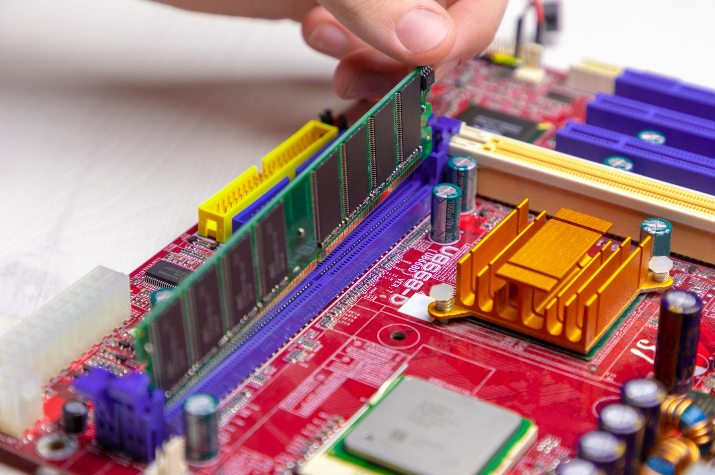
Single Channel
1 RAM stick
Lower bandwidth
Dual Channel
2 identical RAM sticks
Doubles memory bandwidth
📌 Example:
- 1×16GB → Single channel
- 2×8GB → Dual channel (faster)

🧠 Why Dual Channel Matters
- Better gaming performance
- Faster data transfer
- Better integrated GPU performance
- Faster AI dataset handling
Difference can be:
- 5–20% depending on workload

🧩 XMP / EXPO (Very Important)
RAM does NOT run at advertised speed automatically.
You must enable:
- XMP (Intel)
- EXPO (AMD)
In BIOS.
Otherwise:
- 3200 MHz RAM may run at 2133 MHz

🔥 Other Important RAM Concepts

1️⃣ Memory Rank (Single Rank vs Dual Rank)
- Single Rank → One data block
- Dual Rank → Slightly better performance
- Dual rank often faster in real-world multitasking

2️⃣ RAM Form Factor
Desktop → DIMM
Laptop → SO-DIMM
Not interchangeable.

3️⃣ ECC RAM (Error Correcting Code)
Used in:
- Servers
- Workstations
- Scientific systems
Detects & corrects memory errors.
Not required for normal users.

4️⃣ RAM & Integrated Graphics
If using:
- Intel iGPU
- AMD APU
RAM speed matters A LOT
Because GPU uses system RAM.

5️⃣ RAM & AI / Data Science
For your kind of work (AI / SERS / simulations):
- Large datasets → Need higher capacity
- ML training → More RAM reduces disk swapping
- Parallel tasks → Dual channel helps

🧠 Real-World Example
System A
i5 + 8GB + single channel
→ Lag with 15 Chrome tabs
System B
Same i5 + 16GB dual channel
→ Smooth performance
CPU same
RAM changed
Performance improved

🎯 Smart Buying Advice
Students
→ 16GB (2×8GB) DDR4 or DDR5
Developers
→ 16GB minimum
→ 32GB if using VMs
AI / Simulations
→ 32GB recommended

🧠 Final Core Understanding
RAM affects:
- Multitasking
- Stability
- Integrated GPU performance
- Dataset processing speed
- System smoothness
It does NOT increase:
- Raw CPU power
- Gaming FPS (unless RAM was bottleneck)

🏁 One-Line Summary
RAM is your system’s workspace.
Capacity decides how much you can do.
Speed + latency decide how fast you can do it.
Understanding CPU Naming, Performance & Choosing the Right One

1️⃣ Intel vs AMD Naming Structure
🔵 Intel
Tier (Performance Level)
- i3 → Entry level
- i5 → Mid-range
- i7 → High performance
- i9 → Enthusiast / Heavy workloads
Generation (First digits after dash)
Example:
- i5-12400
  - i5 → Tier
  - 12 → 12th Generation
- i7-13700
  - i7 → Tier
  - 13 → 13th Generation

🔴 AMD
Tier
- Ryzen 3 → Entry level
- Ryzen 5 → Mid-range
- Ryzen 7 → High performance
- Ryzen 9 → Enthusiast
Number Series (Generation Family)
Example:
- Ryzen 5 5600X
  - Ryzen 5 → Tier
  - 5000 → Zen 3 generation family
- Ryzen 7 7700X
  - Ryzen 7 → Tier
  - 7000 → Zen 4 generation family

2️⃣ Cores vs Clock Speed (Very Important Concept)
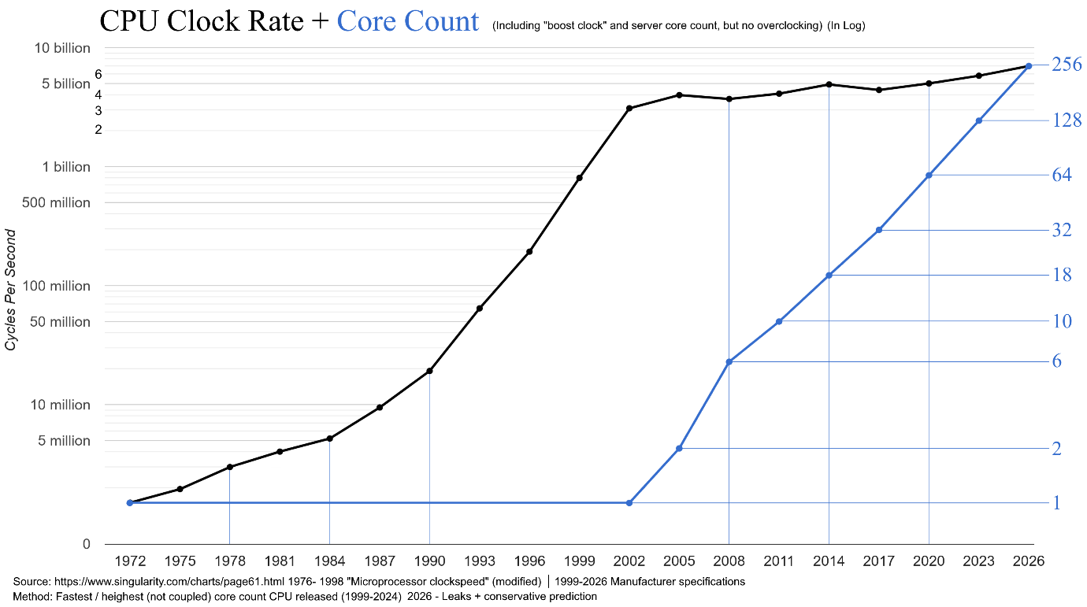
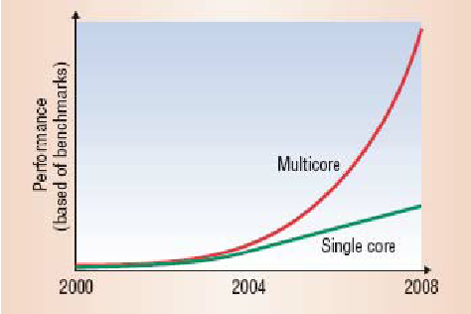

🔹 High Clock Speed → Better for Single Tasks
- Faster response
- Better for:
  - MS Office
  - Browsing
  - Old software
  - Some games
Think of it as:
One very fast worker

🔹 More Cores → Better for Multitasking
- Multiple apps open
- Background tasks
- Compiling code
- Running VMs
- AI models
Think of it as:
Many workers working together

3️⃣ Gaming ≠ Rendering Needs
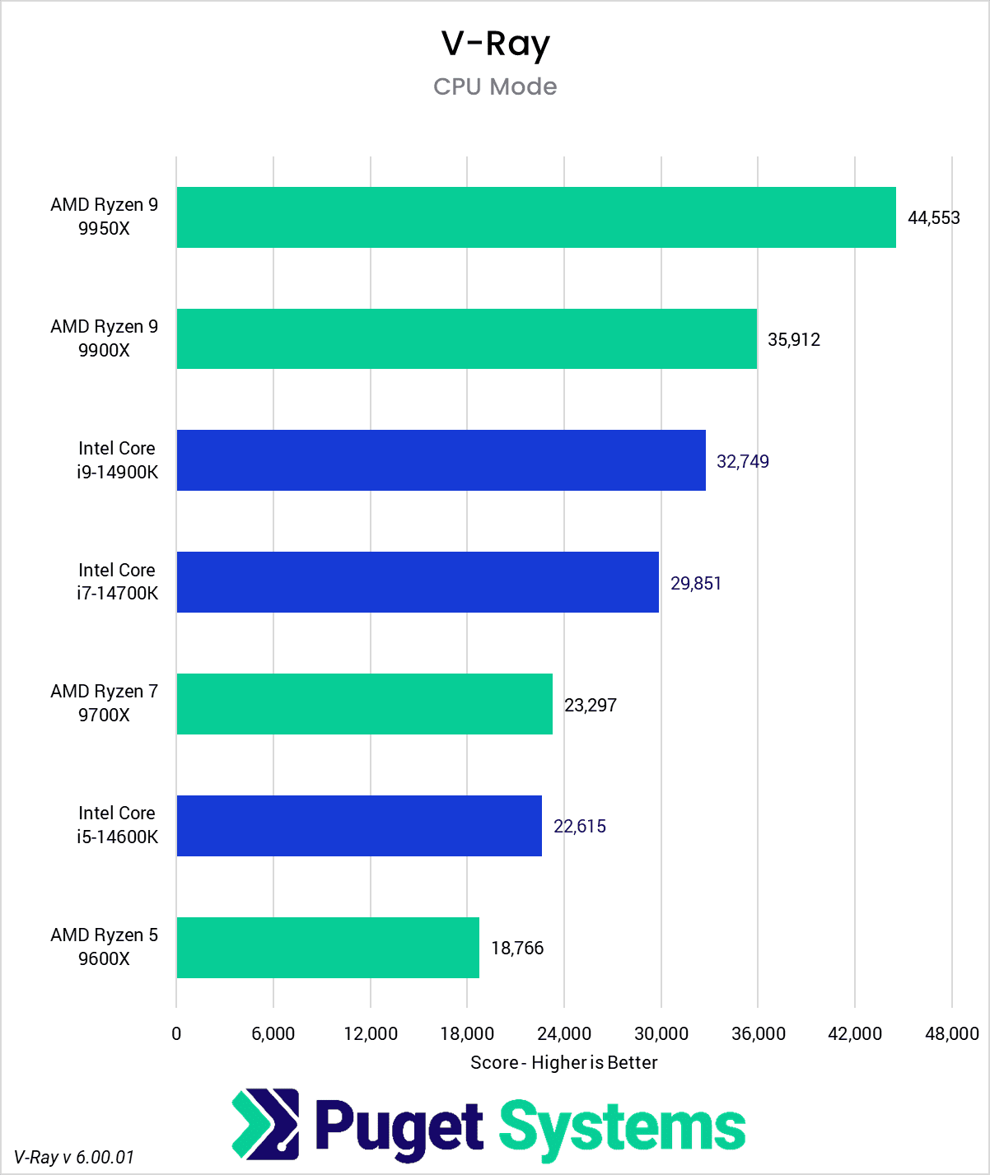
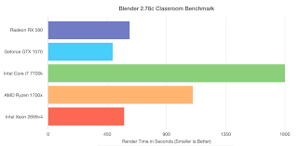
🎮 Gaming
- Needs strong single-core performance
- Most games use 4–8 cores efficiently
- High clock speed matters
🎥 Rendering / AI / Simulation
- Uses all cores fully
- More threads = faster completion
- Clock speed less important than core count

4️⃣ Your Work Decides What Matters
Work Type | What Matters More
Office | Single-core speed
Coding | Cores + threads
Gaming | Clock speed + GPU
Video editing | More cores
AI / ML | More cores + RAM
Virtual machines | Threads

5️⃣ Choosing the Right CPU

✅ Choose Intel If:
- Office work
- Budget PC builds
- Light gaming (no heavy multitasking)
- You want strong integrated graphics
Why?
- Strong single-core speed
- Often smoother in daily tasks
- Good for basic users

✅ Choose AMD If:
- Coding
- Running multiple apps
- Data science / AI
- Simulations
- Virtual machines
- Heavy multitasking
Why?
- More cores per price
- Better parallel performance
- Good long-term value

6️⃣ Real Example Scenarios
👨‍🎓 Student (Office + Browsing)
→ Intel i5 / Ryzen 5 both fine
Clock speed slightly more important
👨‍💻 Developer (VS Code + Docker + Chrome + Python)
→ Ryzen 5 / Ryzen 7 better choice
More threads help
🧠 AI / ML Student (Like you)
→ AMD usually better
More cores help in:
- Model training
- Simulations
- Parallel processing

7️⃣ Final Clear Understanding
- Tier (i3/i5/i7 or Ryzen 3/5/7) → Performance class
- Generation number → Architecture improvement
- Clock speed → Fast single tasks
- Cores → Multitasking power
- Gaming ≠ Rendering needs
- Your workload decides everything

🎯 Simple Final Rule
If your system feels slow when opening apps → need better single-core
If your system hangs when many apps open → need more cores

